Releases notes v1.11


Releases notes
v1.11
Bugs & Change 3
Improvement 4
#512 - Show user system information 4
#508 - User defaut VAT for create line (quote or order) 5
#507 - Make home made gant chart 6
#498 - NC improve 7
#496 - Show delivery note & Invoice in order line 8
#495 - Invoice progress bar 9
#493 - add colors according to need 10
#492 - Make NC from guest order page 11
#491 - Make rate from public link 12
#489 - Delivery Progress 13
#488 - invert the load value by the empty load value 14
#487 - Change public link label 15
#486 - Do not change company if flow history 16
#485 – lead : Change user management 17
#484 - Change drop-down lists with switch buttons 18
#483 - Number of new names 19
#471 - Classification ABC / MFR 20
#472 - Niko niko 21
#480 - Amdec/FMEA 22
#469 - Import Export Create page dedicate 23
#465 - Calendar task (like order) 24
#452 - Kanban filtering by service 25
#451 - Create quote or order from customers page 26

Bugs & Change

#511 - Division by zero bug
#510 - Move selected language to factory setting php
#509 - add log activity php
#506 - Issue with quote table
#505 - Split methods page Blade
#504 - No companie on update select companie
#502 - Fixe psr-4 skipping invalid
#503 - Optimize quote & order show
#501 - On Admin and Accounting controller
#499 - User trigger for change statu of third party
#497 - add doctrine/dbal
#490 - Change order Statu
#473 - Split page
#464 - Filtering, not working with sub task
#463 - Sub contracting, look not concidering like purchase
#459 - Convert statu after quote win
#458 - Photo not working
#457 - Fixe form issue after componant use
#456 - Rename service class
#454 - Avoid warning in IDE from comment class
#453 - Change on migrations
#450 - Refactoring accounting controlers
#449 - production.ERROR: Attempt to read property "component_id" on null
#448 - Refactoring companie controlers

Improvement

#512 - Show user system information

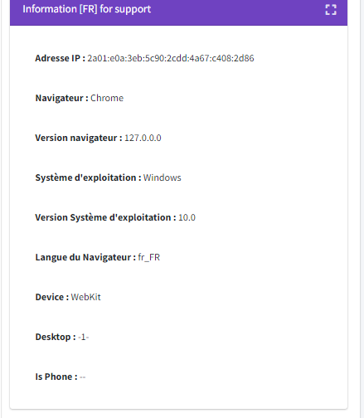

#508 - User defaut VAT for create line (quote or order)

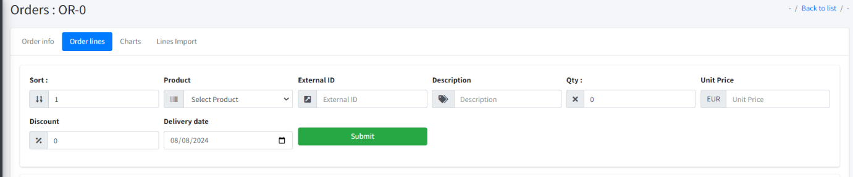

#507 - Make home made gant chart

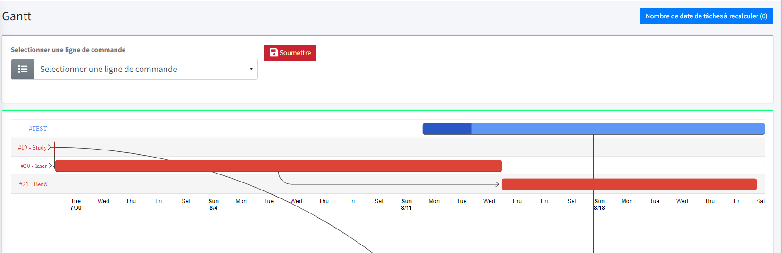

#498 - NC improve

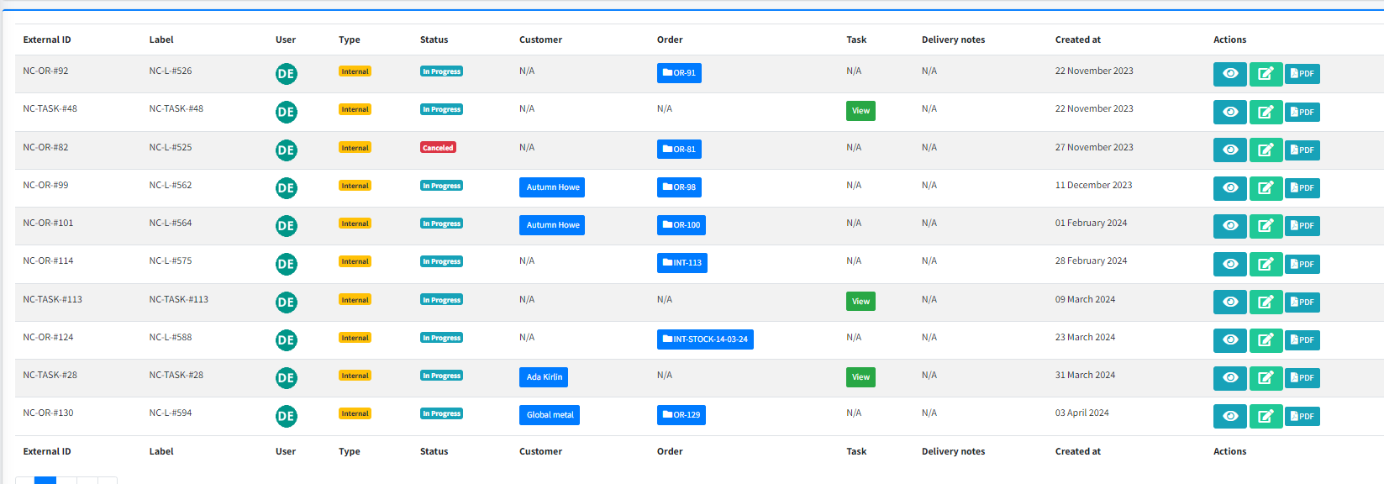

#496 - Show delivery note & Invoice in order line
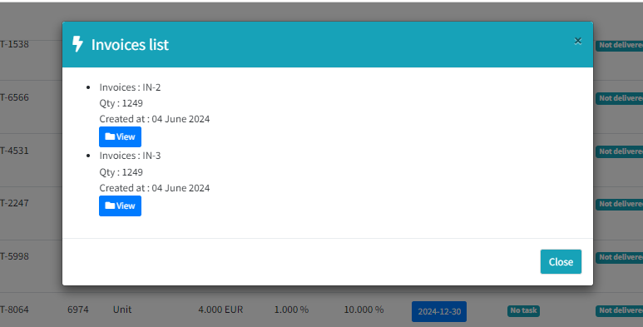

#495 - Invoice progress bar
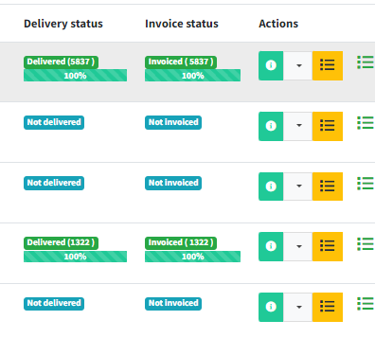

#493 - add colors according to need
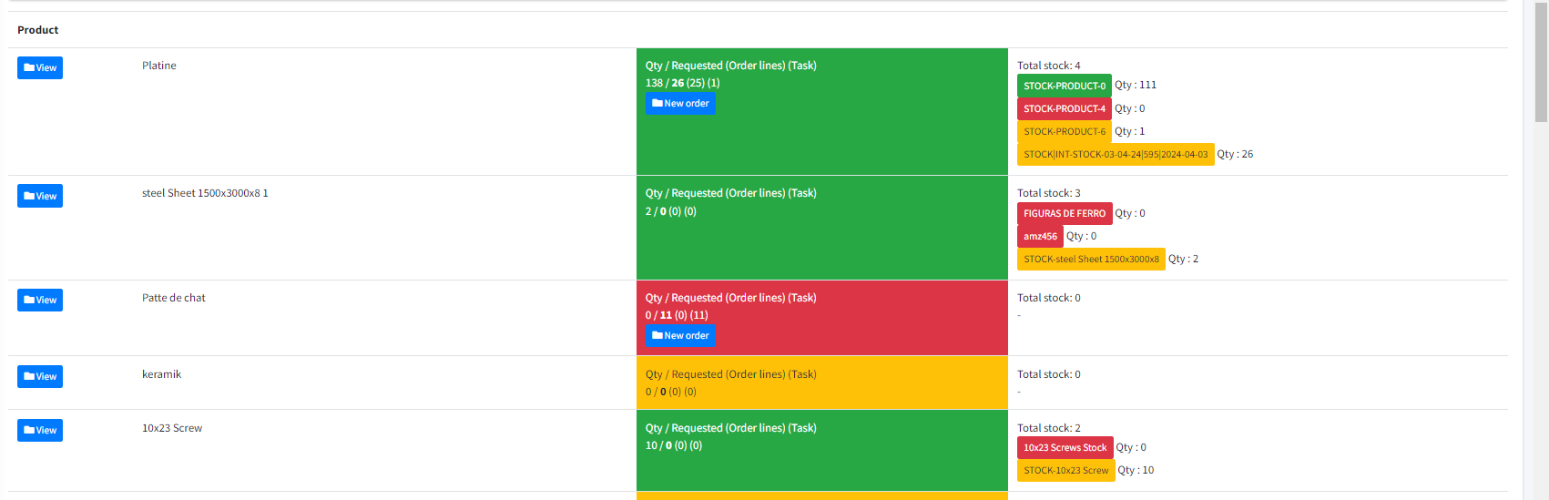

#492 - Make NC from guest order page
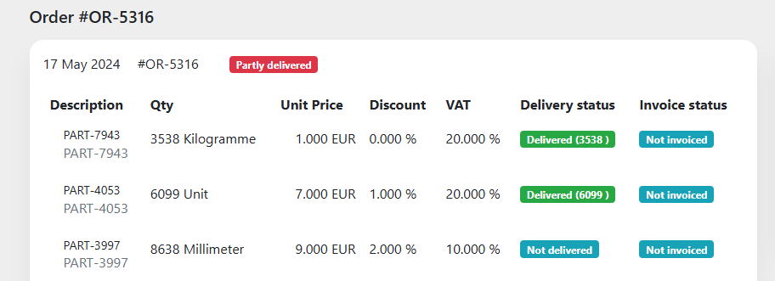
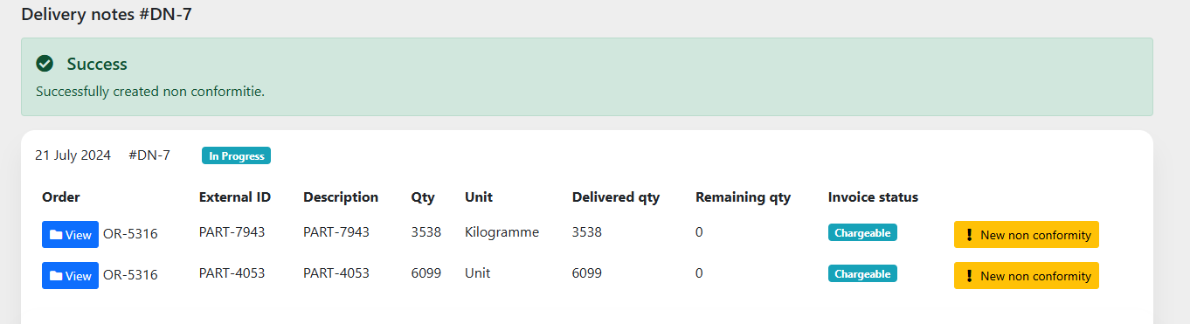

#491 - Make rate from public link
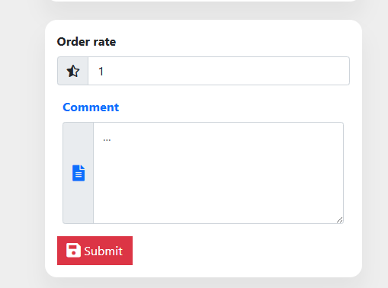

#489 - Delivery Progress

#488 - invert the load value by the empty load value
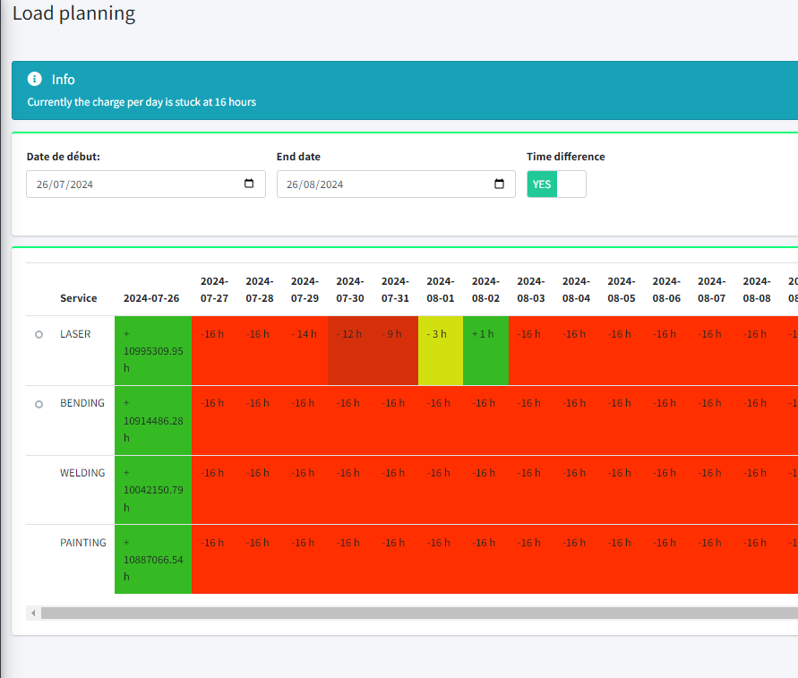

#487 - Change public link label
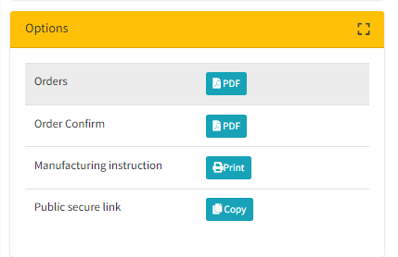

#486 - Do not change company if flow history
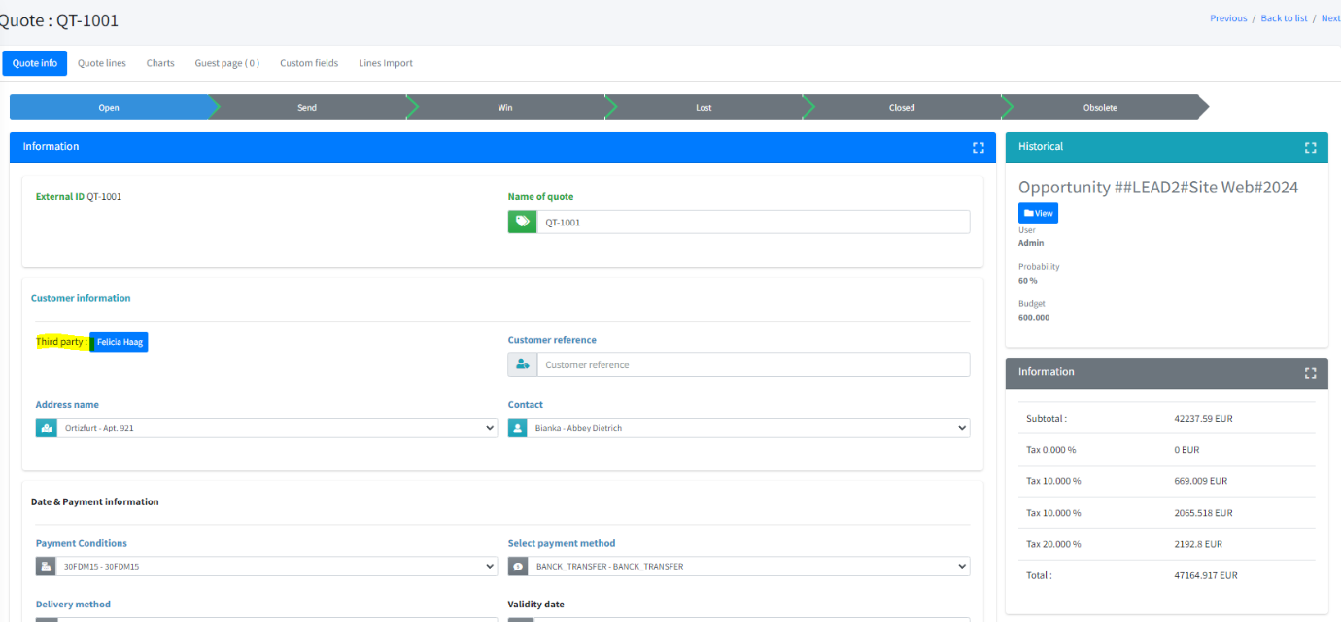

#485 – lead : Change user management
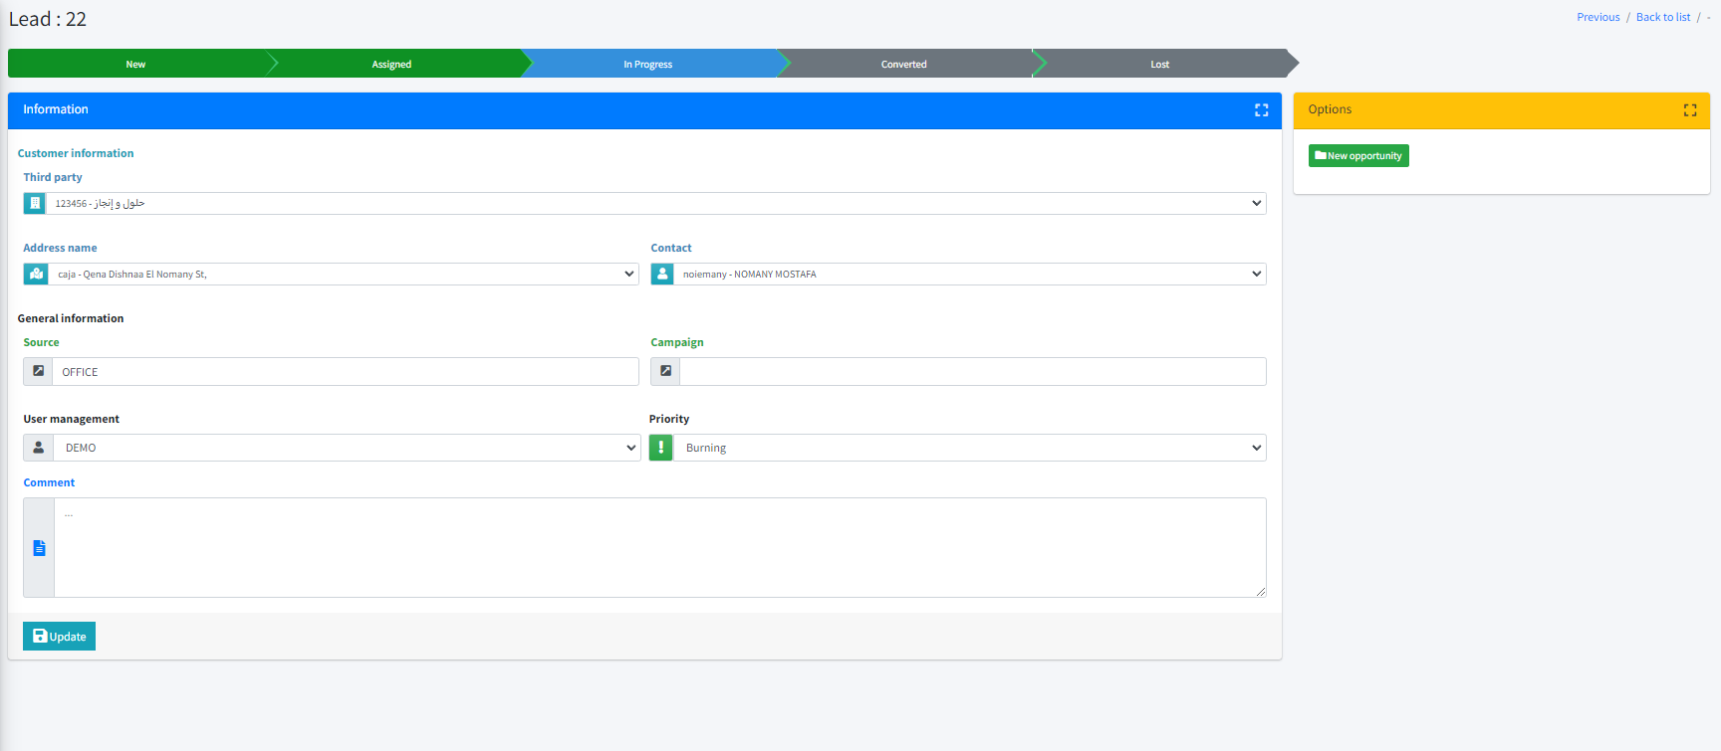

#484 - Change drop-down lists with switch buttons
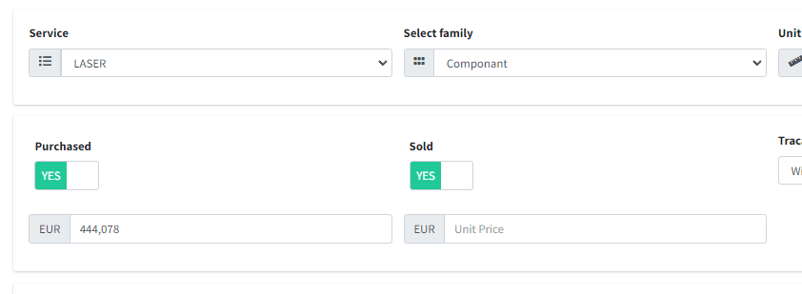

#483 - Number of new names
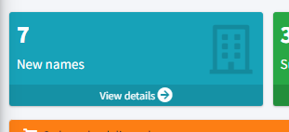

#471 - Classification ABC / MFR
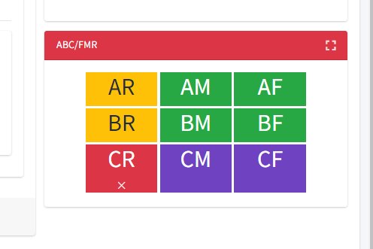

#472 - Niko niko
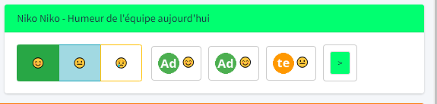

#480 - Amdec/FMEA
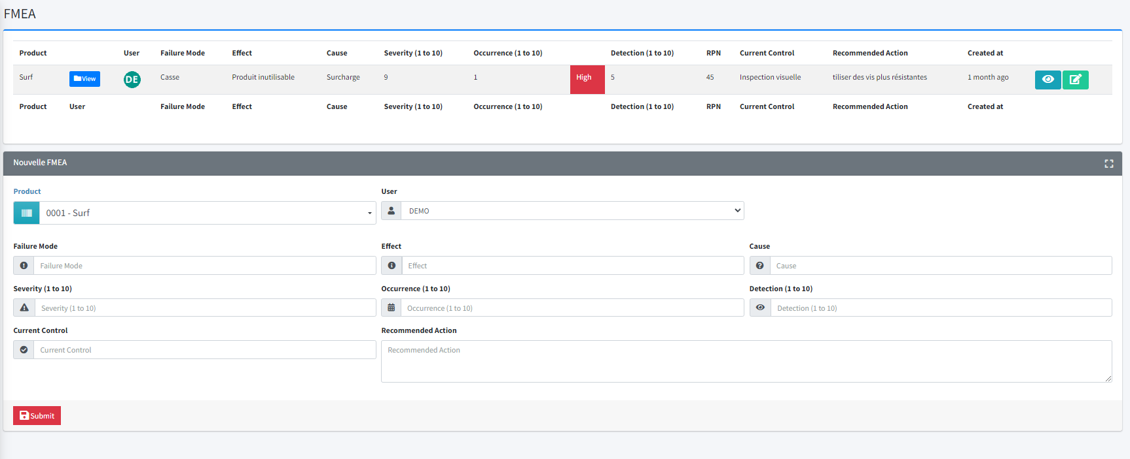

#469 - Import Export Create page dedicate
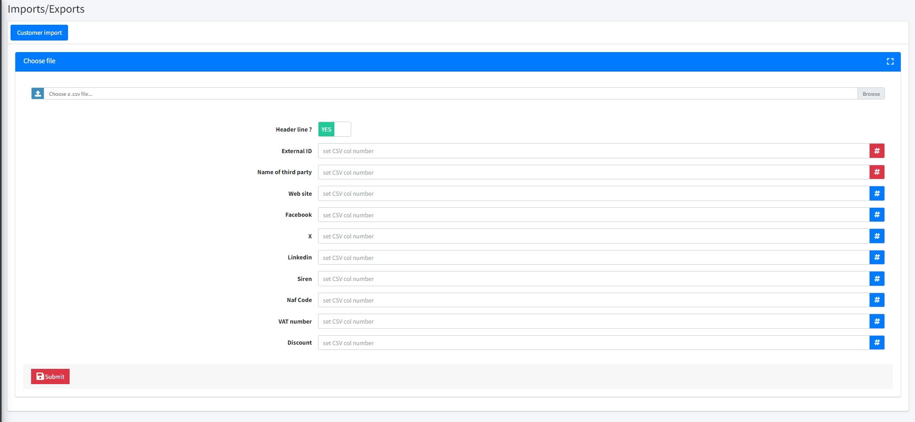

#465 - Calendar task (like order)
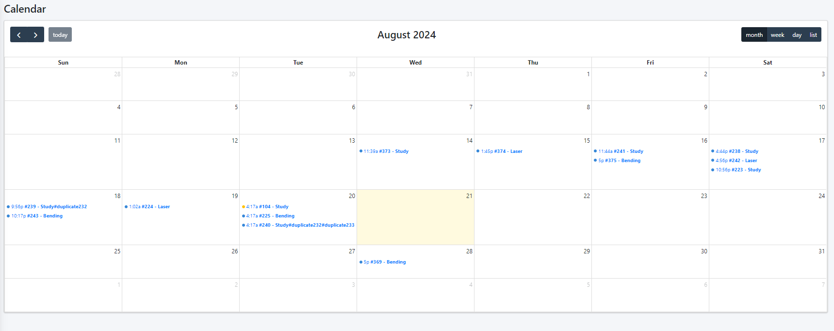

#452 - Kanban filtering by service
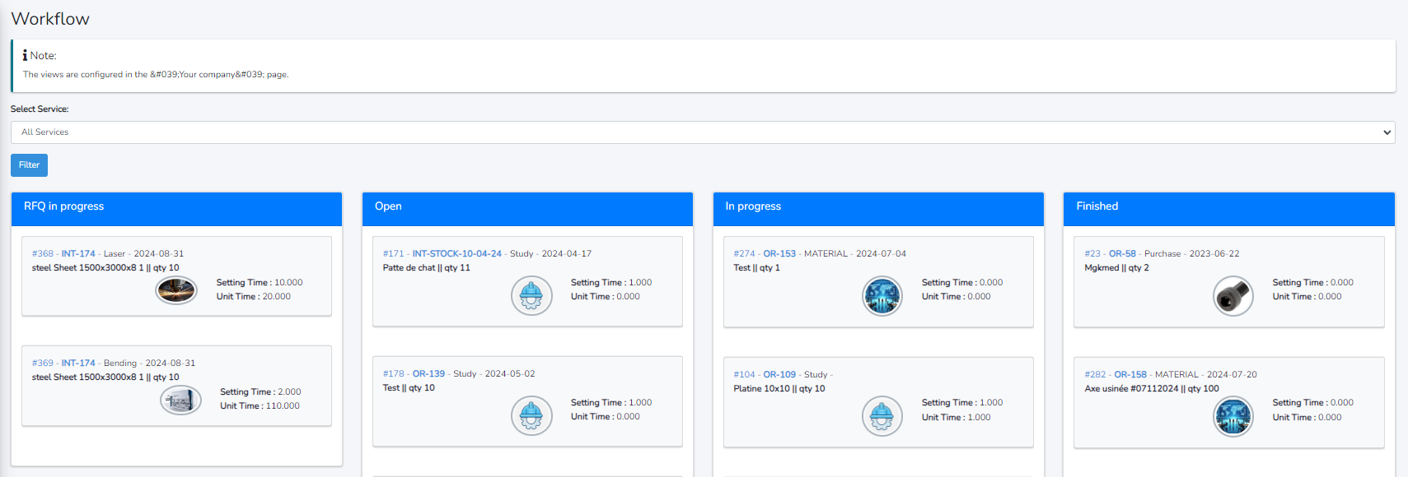

#451 - Create quote or order from customers page
